**Analysis on Heroes of Pymoli dataset**

From the data it can be observed that most purchases are made by male players which is 84% and female players contribute to 14% of the purchases made.

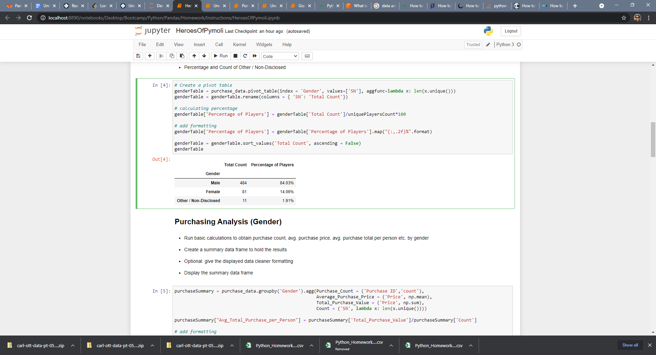

The age-wise analysis shows that the maximum purchases around 45% are made by age group 20-24 years. Next significant purchases are made by age groups 15-19 around 18.6% and 25-29 around 13%.

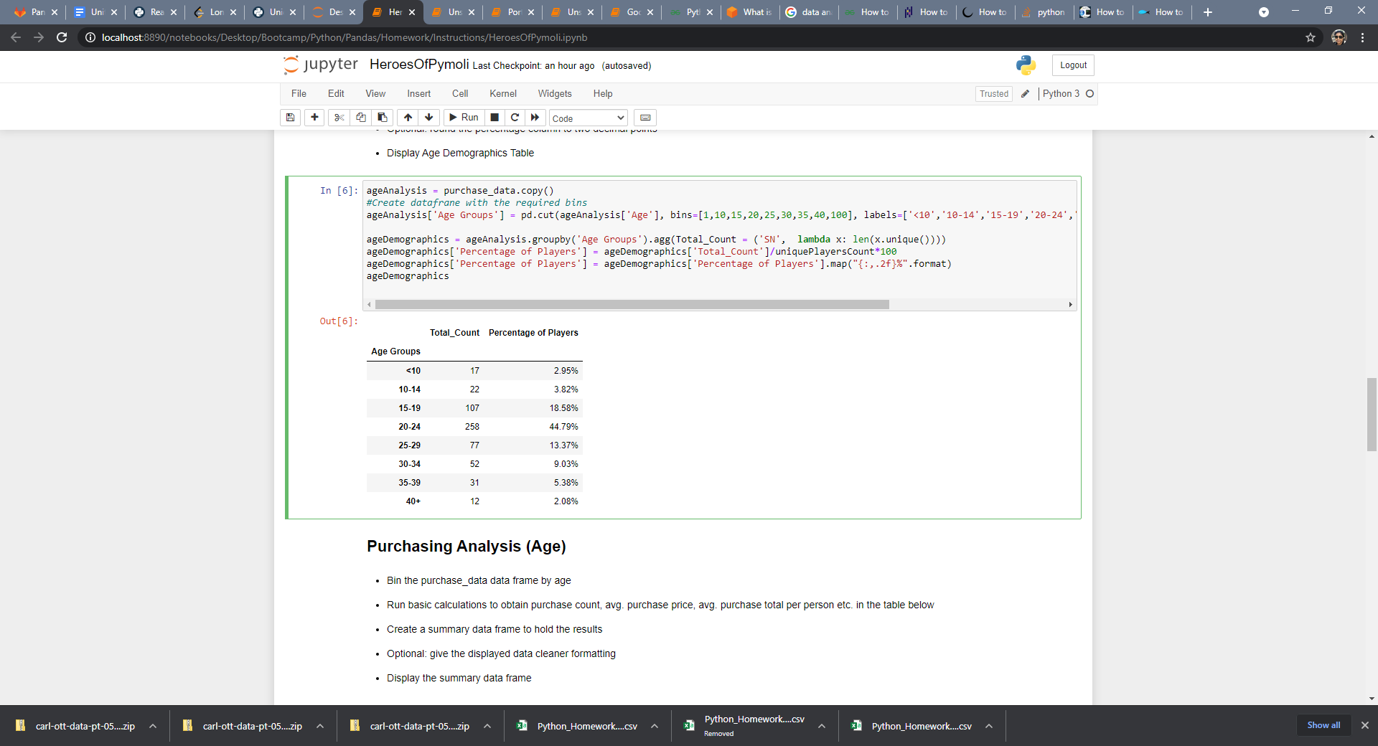

The items that were purchased most is **Final critic**($4.61) 13 times and **Oathbreaker, Last Hope of the Breaking Storm**($4.23) 12 times.

